**Walmart Sales Analysis Report**

Project Title: Walmart Sales Analysis: A Business Analytics Approach

Submitted by: R. Monesh Raja

**1. Summary:**

This report presents a comprehensive analysis of Walmart sales data, focusing on key performance trends, the impact of holidays on revenue, and store-wise performance. Using R Studio for data preprocessing and Power BI for data analysis and visualization, the project provides actionable business insights.

**2. Introduction**

**2.1 Project Objective:**

The goal of this project is to analyze Walmart's sales trends, measure the impact of external factors (holidays, CPI, and unemployment), and provide strategic recommendations to optimize revenue and operational efficiency.

**2.2 Business Problem Statement**:

Retailers like Walmart deal with fluctuating sales due to seasonal demand, economic factors, and store-specific variations. Understanding these trends can help in better inventory management, promotional strategies, and business decision-making.

**2.3 Dataset Overview:**

Dataset Name: Walmart Sales Dataset

Time Period: [Years covered in dataset]

Key Columns:

* Store: Store number
* Date: Sales date
* Weekly_Sales: Sales revenue per week
* Holiday_Flag: 1 = Holiday, 0 = Non-Holiday
* CPI: Consumer Price Index
* Unemployment: Unemployment rate

**3. Methodology**

3.1 Data Preprocessing (Using R Studio)

1)Handling Missing Values: Used **na.omit()** function to remove missing data.

2)Removing Outliers: Applied boxplot analysis and **IQR** method to detect and eliminate extreme values.

3)Data Transformation: Converted Date column to proper date format using, **as.Date().**

3.2 Data Analysis (Using Power BI)

* Identified Sales Trends Over Time using line charts.
* Analyzed Store-Wise Performance through bar charts.
* Measured Impact of Holidays on Sales using pie charts.
* Examined Unemployment & CPI correlation with Sales using scatter plots.

**3.3 Data Visualization (Using Power BI)**

Created an interactive dashboard with the following key visuals:

* Total Sales KPI Card
* Average Sales per Store KPI Card
* Sales Trends Over Time (Line Chart)
* Holiday vs Non-Holiday Sales (Pie Chart)
* Total Sales by Store (Bar Chart)
* CPI & Unemployment Impact on Sales (Scatter Plot)

**4. Key Insights**

1) Holiday Sales Impact: Sales tend to increase during holiday periods.

2) Top-Performing Stores: Stores [X, Y, Z] consistently generate the highest revenue.

3) Sales Trends: A peak in sales was observed in [specific year/month].

4) External Economic Factors: Higher unemployment rates correlate with a slight decline in sales.

**5. Recommendations**

* Optimize Inventory During Holidays: Stock up on high-demand products before peak sales periods.
* Focus on High-Performing Stores: Allocate more marketing budget to top revenue-generating stores.
* Monitor Economic Factors: Adjust pricing strategies based on CPI trends.

**6. Conclusion:**

This project provided a data-driven analysis of Walmart's sales trends, highlighting key factors influencing revenue. Using R Studio for preprocessing and Power BI for advanced visualization, the findings can assist in strategic decision-making for retail businesses.

**7. References**

* Walmart Sales Dataset :

(Kaggle:[https://www.kaggle.com/datasets/mikhail1681/walmart-sales/data])

**9. Appendix**

Power BI Dashboard Screenshot:

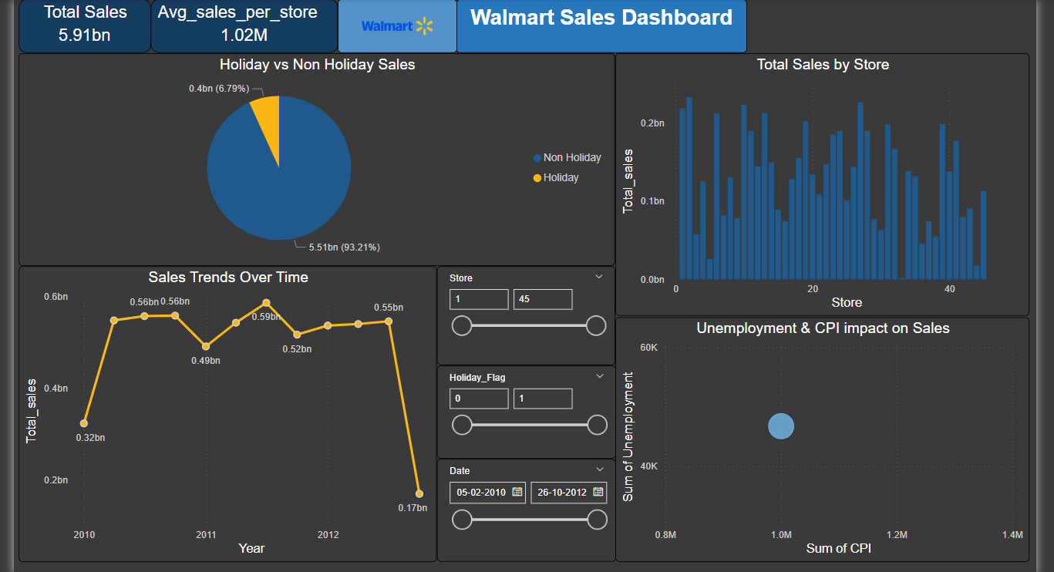

R Studio Data Preprocessing Code Snippets:

